**which command:-**

which command displays the pathname of file.

**Path of cat:-**



As per the above screenshot, path of **cat** is **/bin/cat**.

**Path of date:-**

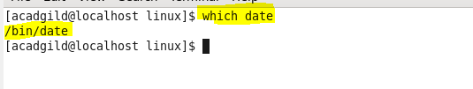

As per the above screenshot, path of **date** is **/bin/cat**.

**Path of who:-**

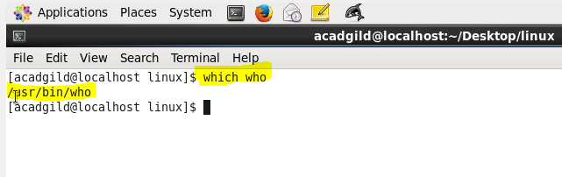

As per the above screenshot, path of **who** is **/usr/bin/who**

Like this, we can display the pathname of any files using which command.